A Business Data Management Study of Customer Demand and Operational Challenges at Metro Hotel and Restaurant, Singur

A Proposal report for the BDM capstone Project

Submitted by

Name: SAMPRIKTA MALIK
Roll number: 21F3002038



IITM Online BS Degree Program,
Indian Institute of Technology, Madras, Chennai
Tamil Nadu, India, 600036
Contents Page
1 Executive Summary and Title 3
2 Organisation Background 3
3 Problem Statement 4
3.1 Problem Statement 1 4
3.2 Problem Statement 2 4
3.3 Problem Statement 3 4
4 Background of the Problem 4
5 Problem Solving Approach 5
6 Expected Timeline 6
7 Expected Outcome 7

Declaration Statement
I am working on a project titled “A Business Data Management Study of Customer Demand and Operational Challenges at Metro Hotel and Restaurant, Singur.” I extend my sincere appreciation to Metro Hotel and Restaurant, Singur, for providing the necessary information and cooperation that enabled me to undertake this project.
I hereby assert that the data presented and assessed in this project report is genuine and precise to the utmost extent of my knowledge and capabilities. The data has been gathered through primary sources and carefully analyzed to assure its reliability.
Additionally, I affirm that all procedures employed for the purpose of data collection and analysis have been duly explained in this report. The outcomes and inferences derived from the data are an accurate depiction of the findings acquired through thorough analytical procedures.
I am dedicated to adhering to the information of academic honesty and integrity, and I am receptive to any additional examination or validation of the data contained in this project report.
I understand that the execution of this project is intended for individual completion and is not to be undertaken collectively. I thus affirm that I am not engaged in any form of collaboration with other individuals, and that all the work undertaken has been solely conducted by me. In the event that plagiarism is detected in the report at any stage of the project's completion, I am fully aware and prepared to accept disciplinary measures imposed by the relevant authority.
I agree that all the recommendations are business-specific and limited to this project exclusively, and cannot be utilized for any other purpose with an IIT Madras tag. I understand that IIT Madras does not endorse this.

Signature of Candidate: 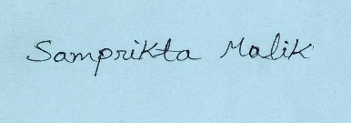
Name: SAMPRIKTA MALIK
Date: 12/02/2026

1 Executive Summary and Title
Project Title: A Business Data Management Study of Customer Demand and Operational Challenges at Metro Hotel and Restaurant, Singur
Metro Hotel and Restaurant is a family-run restaurant established in 1997 and located in Singur Bazar, Hooghly, West Bengal. The restaurant serves freshly prepared Indian and Chinese cuisine and has built a strong local reputation through consistent food quality, good service, and customer trust over the years.
In recent times, the restaurant has faced operational challenges due to increased competition and the absence of a structured data management system. Daily sales, customer demand, and inventory-related information are recorded manually using pen-and-paper billing methods. This limits the owner’s ability to analyze sales trends, understand customer demand patterns, and make informed business decisions related to pricing, inventory planning, and operational efficiency.
This project aims to analyze these operational challenges using a data-driven approach. Primary data will be collected from billing records, purchase registers, and discussions with the restaurant owner. The data will be digitized, cleaned, and analyzed using basic business analytics techniques to identify demand patterns, peak business hours, and inefficiencies in current processes.
The expected outcome of this project is to provide actionable insights that can help improve demand planning, reduce operational inefficiencies, and support better decision-making, ultimately contributing to improved profitability and sustainability of the restaurant.
2 Organization Background
Metro Hotel and Restaurant is a family-run food business established in 1997 and located at Singur Bazar on S. N. Mallick Road, Hooghly, West Bengal. The restaurant is situated beside Singur Mahamaya High School and opposite Singur Railway Station, making it easily accessible to local residents, students, and commuters. It is owned and managed by Shri Pranab Ghosh. Since its establishment, the restaurant has been serving freshly prepared Indian and Chinese dishes. In its early years, the restaurant faced very little competition and was able to grow steadily. Over time, as more restaurants entered the local market, competition increased. Despite this, Metro Hotel and Restaurant has maintained its customer base due to its consistent food quality, reasonable pricing, and friendly customer service.

3 Problem Statement (Listed as objectives)
The objective of this project is to understand the main operational challenges faced by Metro Hotel and Restaurant due to the use of manual record-keeping. Since sales and billing are recorded on paper, it becomes difficult to understand customer demand, busy hours, and food item sales. This project aims to use basic data analysis to support better planning and decision-making.
3.1 Problem Statement 1: To study daily sales records in order to understand busy hours and high-demand days.
3.2 Problem Statement 2: To analyze which food items are sold more during peak hours so that shortages of raw materials can be reduced.
3.3 Problem Statement 3: To understand the difficulties caused by manual billing and suggest simple data-based improvements for daily operations.
4 Background of the Problem
Metro Hotel and Restaurant currently relies on manual record-keeping and pen-and-paper billing for all daily transactions. While this traditional approach has worked for years, it inherently limits the owner’s ability to understand detailed sales patterns, customer demand trends, and item-wise performance. Without structured or digitized records, it is difficult to analyze historical data, forecast future demand, and plan purchases of raw materials. This situation leads to frequent shortages of key ingredients, especially during peak hours, when demand is highest.
Internally, the absence of a systematic data recording process creates challenges in organizing and retrieving past sales records. Daily operational decisions are based on memory or approximate estimates rather than data insights. This also makes it difficult to recognize which dishes are most popular on different days or during different customer segments (such as weekdays vs weekends). As a result, inventory planning becomes reactive rather than proactive, increasing the likelihood of stockouts.
Externally, the restaurant operates in a competitive local market where customer expectations are rising, and nearby alternatives are readily available. In such an environment, delayed decision-making and operational inefficiencies can affect customer satisfaction and revenue. Therefore, understanding and addressing these problems through basic data analysis is critical for improving planning and daily operations.
5 Problem Solving Approach
To address the operational challenges faced by Metro Hotel and Restaurant, this project proposes a structured and data-driven problem-solving approach. The study will primarily rely on primary data collected from the restaurant’s existing manual records and interactions with the owner. Since the restaurant currently maintains billing and sales information using pen and paper, the first step of the approach will involve organizing and converting this unstructured data into a digital format for analysis.
- Data Collection and Structuring:
The initial phase will focus on collecting historical billing records, daily sales registers, and basic purchase information. These records will be digitized into spreadsheets to create a structured dataset. This step will help in organizing item-wise sales, date-wise transactions, and time-based demand. Basic data cleaning methods will be applied to remove errors, duplicates, and incomplete entries to ensure data reliability.
- Descriptive Data Analysis:
Once the data is structured, descriptive analytics will be used to understand the current operational patterns of the restaurant. This includes analyzing daily sales volume, identifying peak business hours, and comparing weekday and weekend demand. Simple tools such as pivot tables, summary statistics, and charts will be used to visualize sales trends and customer flow, especially during lunch hours when demand is highest.
- Demand and Inventory Analysis:
To address the issue of frequent ingredient shortages, particularly for high-demand items such as chicken, item-wise sales analysis will be conducted. This analysis will help identify frequently ordered dishes and approximate demand levels during peak periods. By examining historical sales patterns, the study aims to support better daily purchasing decisions and reduce the risk of stock shortages without increasing excess inventory.

- Evaluation of Manual Record-Keeping Practices:
The project will also examine the limitations of manual billing and record maintenance. The impact of unstructured data on demand visibility, inventory planning, and operational efficiency will be analyzed. Based on these observations, simple data management improvements—such as maintaining basic digital sales records—will be proposed, keeping in mind the restaurant’s scale and resource constraints.
Overall, the problem-solving approach focuses on simple and practical methods that are easy to apply. The aim is to help the restaurant understand customer demand better, reduce ingredient shortages, and make better daily decisions using the data that is available.

6 Expected Timeline
6.1 Work Breakdown Structure:
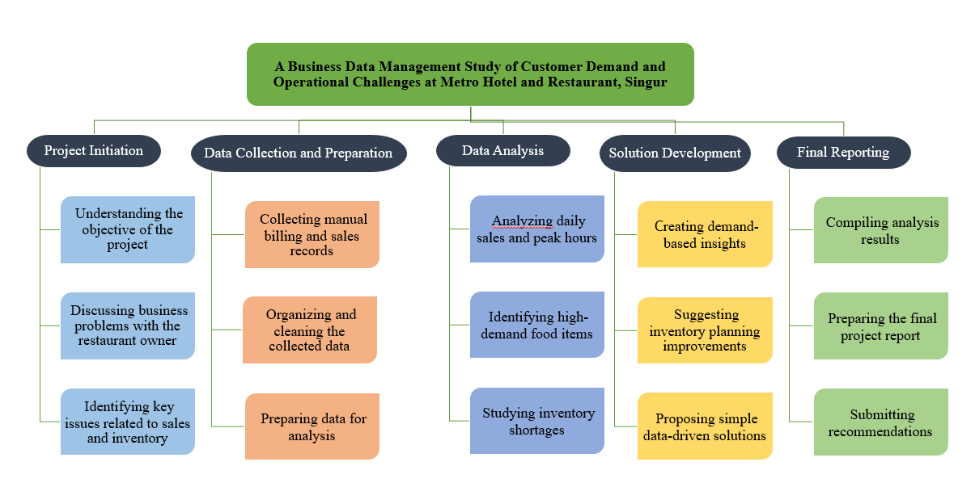

6.2 Gantt chart:
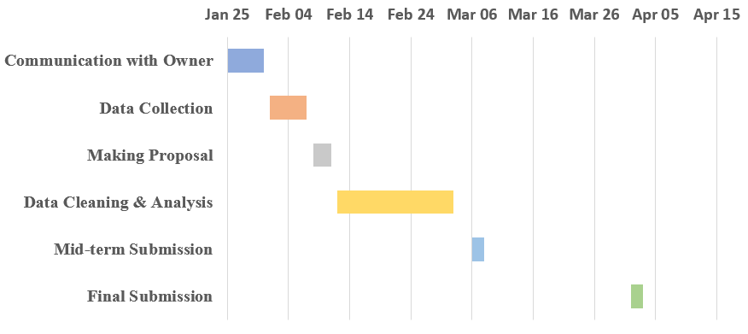

7 Expected Outcome
- Improved Operational Understanding: To provide clear and practical insights that help Metro Hotel and Restaurant improve its daily operations using data analysis.
- Identification of Demand Patterns: To identify peak business hours, high-demand food items, and customer order patterns by organizing and analyzing manually recorded sales data.
- Better Inventory Planning: To support more effective purchase planning and reduce raw material shortages during busy periods.
- Data-Driven Decision Making: To improve understanding of item-wise sales trends for better operational and inventory-related decisions.
- Structured Record Management: To recommend simple and practical methods for maintaining organized sales records for future analysis.

